Design Principles - Loose Coupling
# Source: AI Source: Provided by: [Data Path: Persons Table -> ID Column: 1, Name_En Column: Motasem Essam] -> From: [ChatGPT] on [1/23/2026]
Loose Coupling is the principle of designing components so that changes in one component have minimal impact on others.
👉 Think of it like modular furniture: each piece stands alone and can be moved or replaced without affecting the rest.

🔑 Key Points
# Source: AI Source: Provided by: [Data Path: Persons Table -> ID Column: 1, Name_En Column: Motasem Essam] -> From: [ChatGPT] on [1/23/2026]
- Components communicate through well-defined interfaces or APIs
- Reduces dependencies between modules
- Makes systems easier to maintain, test, and extend
- Essential for scalable and flexible architectures

❌ Bad Example
# Source: AI Source: Provided by: [Data Path: Persons Table -> ID Column: 1, Name_En Column: Motasem Essam] -> From: [ChatGPT] on [1/23/2026]
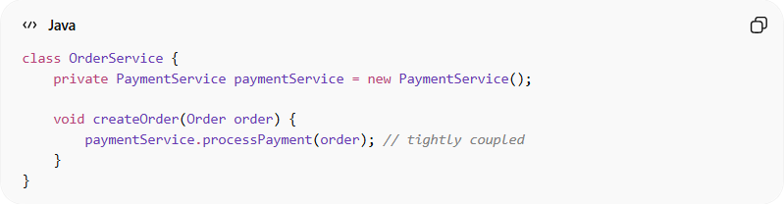
class OrderService {
private PaymentService paymentService = new PaymentService();

void createOrder(Order order) {
paymentService.processPayment(order); // tightly coupled
}
}
Problems:
- OrderService directly depends on PaymentService
- Hard to replace PaymentService with another implementation
- Changes in PaymentService may break OrderService

✅ Good Example
# Source: AI Source: Provided by: [Data Path: Persons Table -> ID Column: 1, Name_En Column: Motasem Essam] -> From: [ChatGPT] on [1/23/2026]
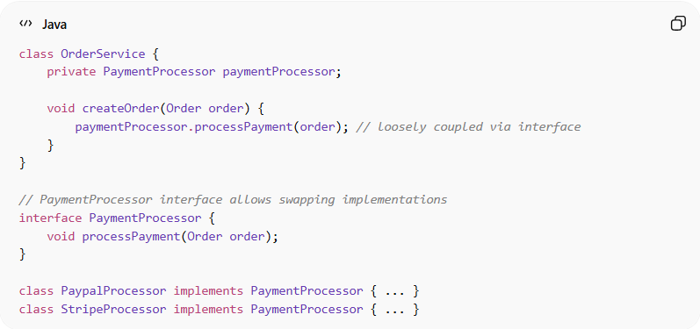
class OrderService {
private PaymentProcessor paymentProcessor;

void createOrder(Order order) {
paymentProcessor.processPayment(order); // loosely coupled via interface
}
}

// PaymentProcessor interface allows swapping implementations
interface PaymentProcessor {
void processPayment(Order order);
}

class PaypalProcessor implements PaymentProcessor { ... }
class StripeProcessor implements PaymentProcessor { ... }
Benefits:
- Modules can evolve independently
- Easier to replace or upgrade components
- Supports testability via mocks or stubs
- Promotes flexible and maintainable architecture

⚡ When to Apply
# Source: AI Source: Provided by: [Data Path: Persons Table -> ID Column: 1, Name_En Column: Motasem Essam] -> From: [ChatGPT] on [1/23/2026]
- In service-oriented, microservices, or layered architectures
- When designing APIs or reusable modules
- Always aim for interfaces or abstractions instead of direct dependencies

